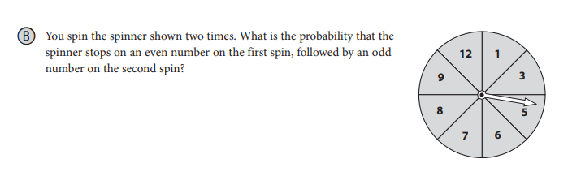

After you answer the question above, also state whether these are INDEPENDENT or DEPENDENT events. EXPLAIN!

2.)

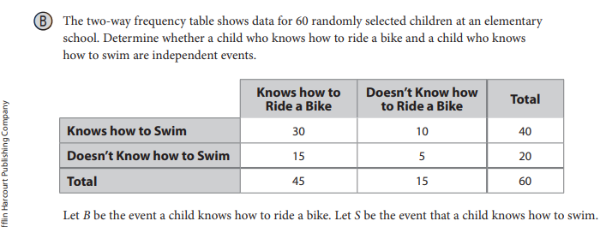

3.
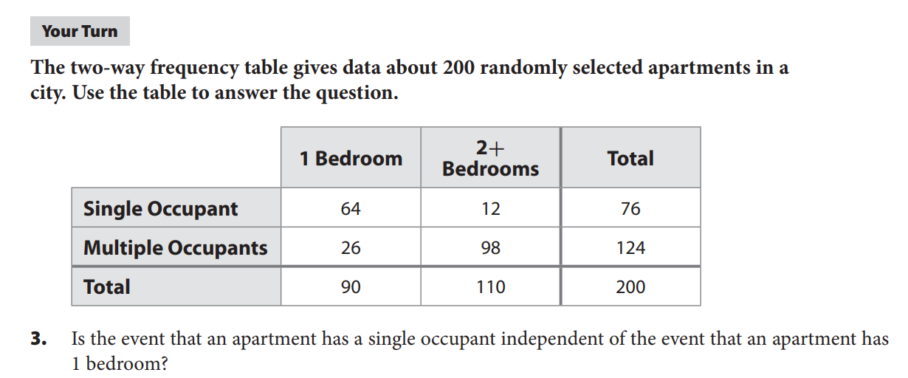

4.

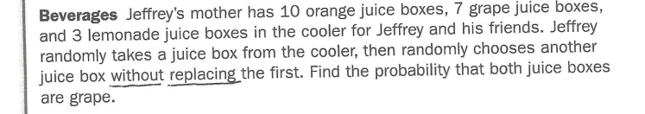

Also, are these events INDEPENDENT or DEPENDENT? Why?

5.
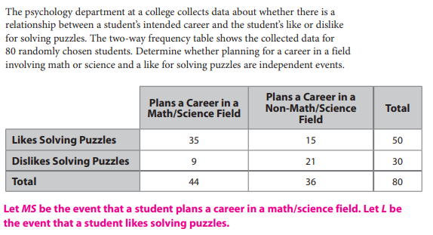

6.
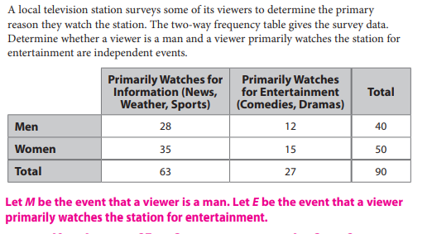

7.
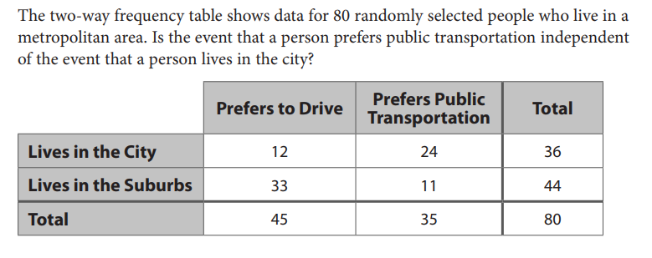
You can use T for “public transportation” and C for “lives in the city”.

8.

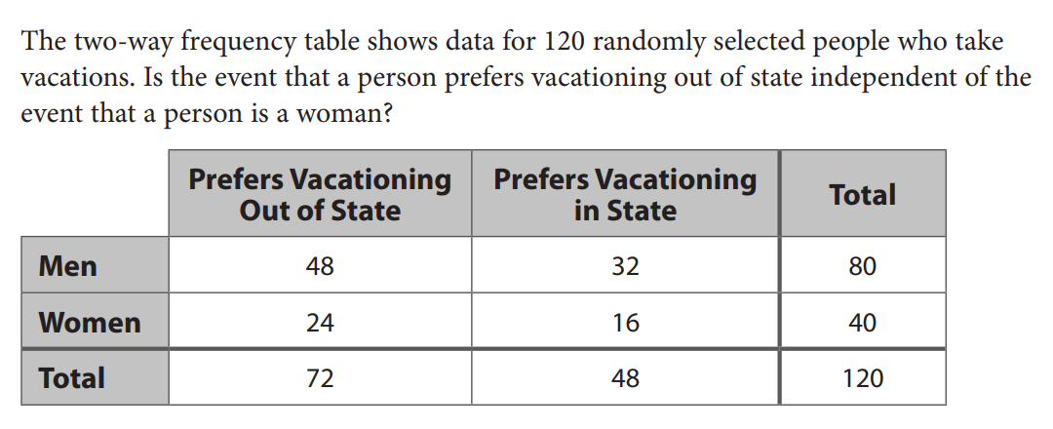

9.

