NAME:

Student Self-Assessment of Engineering

3.) Improve:
Here is what would make my design better and why...

5.) Test:
Here are the data I collected .. .
1.) Ask:

Here is what I am wondering about before I plan my design ...

I am doing the work of a mechanical engineer.

2.) Plan:
Here are my design ideas for the project ...

4.) Create:
Here is what I think about what I made compared to what I planned, and here is what I think will happen when I test it ...

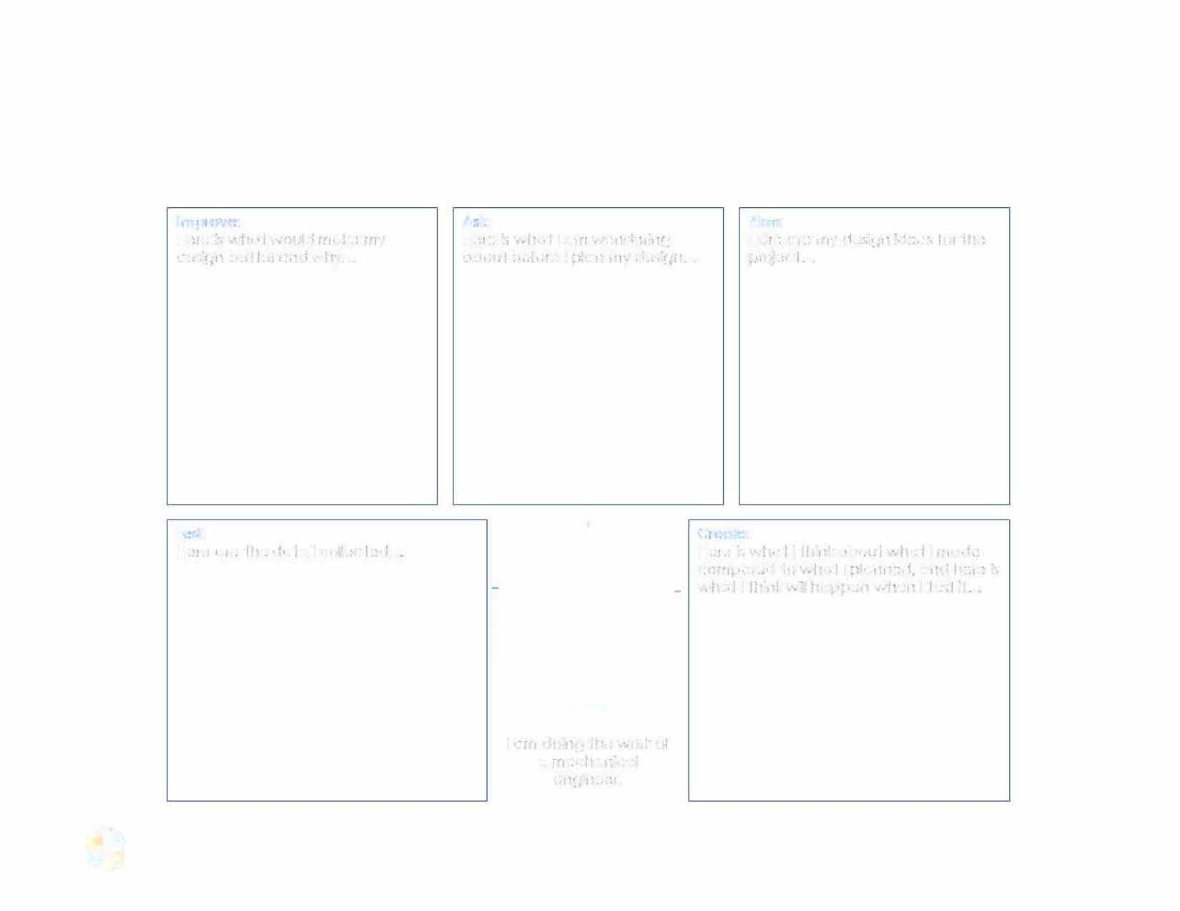

-� Integrated STEM Unit Planner: Geometry - Design a Windmill

Page15

